PRESS RELEASE

COMMUNICATIONS AND MEDIA TEAM OF THE 2023 ASEAN SUMMIT

No.18/SP/TKM-ASEAN2023/ENG/5/2023

MCI Minister Visits Labuan Bajo to Review ASEAN Summit Media Service Readiness

West Manggarai, 2 May 2023 - Communications and Informatics Minister (MCI Minister), Johnny G. Plate, the Chief of Presidential Staff, Moeldoko, and national and local editors in chief visited Labuan Bajo of West Manggarai Regency, East Nusa Tenggara Province, Tuesday, 2 May.

The visit was to review the readiness of several venues set to host the series of events of the 42nd ASEAN Summit in 2023, including the Meruorah Hotel which is set to host the retreat, the Ayana Hotel for dinner of ASEAN Heads of State, and Bintang Flores Hotel for the Media Center which will support good public communications of the event.

The journalistic visit was participated by 20 national mass media editors in chief, 9 NTT media editors in chief, 17 national journalists, and 9 local journalists. Overall, the visit was made to review the readiness of the organization of the international event to be held in 9-11 May, especially the provision of media services.

"We want the standard of media services at the ASEAN Summit to be on par with last year’s G20 Summit in Bali by adjusting to the conditions of Labuan Bajo," said Johnny G. Plate who is also in charge of Communication and Public Relations in the National Committee for the 42nd ASEAN Summit.

The media center set up for ASEAN Summit journalists will be completed with various facilities to facilitate media coverage, including workspaces, press conference rooms, mini studios, and internet networks. The Media Center will distribute press release, photo, and video feed from the summit venues to journalists. The committee recorded 319 registered and accredited journalists, consisting of local, national, ASEAN regional, and global journalists.

"The media center will operate from 6—12 May, equipped with an internet network of fiber optics, satellites, and base transceiver stations with high capacity and speed, both 4G and 5G," said Johnny Plate.

MCI Minister hopes that the media will cover and report on the substance of the meetings and other aspects of the 42nd ASEAN Summit 2023. "The success of ASEAN Summit is also determined by how the media transmits information about the ASEAN Summit," said Minister Johnny.

Meanwhile, Moeldoko, also the Communication and Public Relations Team's member for the 42nd ASEAN Summit 2023 national committee, added that Indonesia is experienced in managing public communications and media centers during the G20 Summit. "Well, that experience has become a reference for organizing the ASEAN Summit now," he said.

Tuesday evening, 2 May, MCI Minister, the Chief of Presidential Staff, and the Secretary to the Ministry of Tourism and Creative Economy, Ni Wayan Giri, continued discussions with media editors in chief and journalists. Several media leaders provided input and suggestions for improving the organization of of the Summit in Labuan Bajo. (Kominfo/TR/Elvira)

***

For more information, please contact:

Director General of Public Information and Communications of the Ministry of Communications and Informatics - Usman Kansong (0816785320)

Get other information at http://asean2023.id, https://infopublik.id/kategori/asean-2023, and https://indonesia.go.id/kategori/ragam-asean-2023

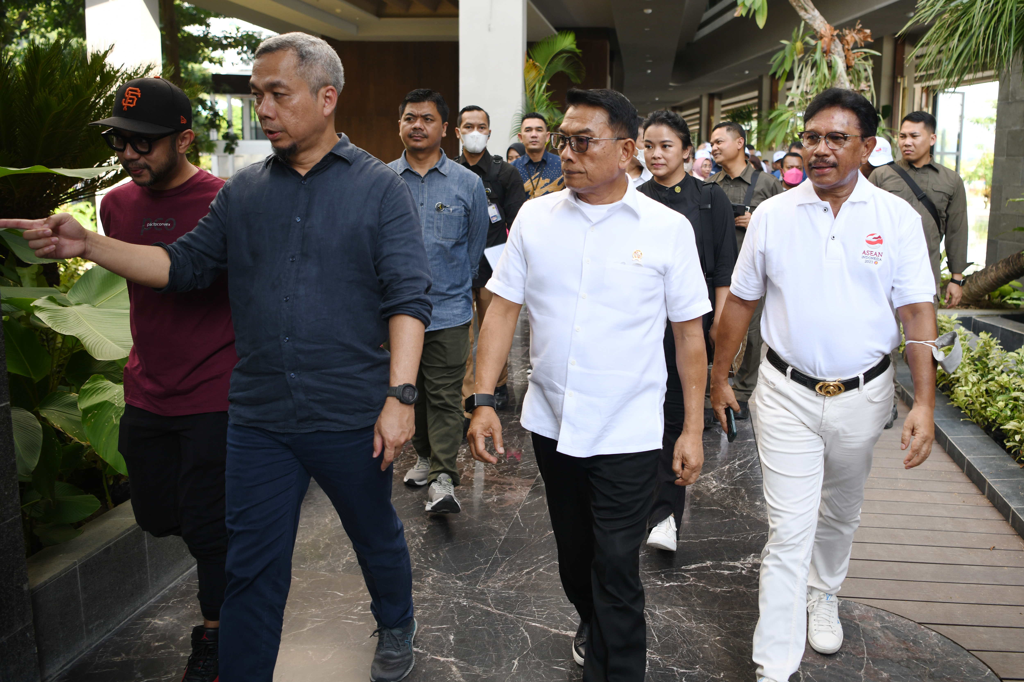

MCI Minister Johnny G. Plate, the Chief of Presidential Staff, Moeldoko, the MCI Director General of Information and Public Communications Usman Kansong, and national and local media editors in chief visited Labuan Bajo of West Manggarai Regency, East Nusa Tenggara Province, Tuesday 2 May 2023. The visit was to review the readiness of several venues set to host series of events of the 42nd ASEAN Summit 2023. (Photo: Public Relations of the Ministry of Communications and Informatics)

